Talking to Your Kids about COVID-19 (Coronavirus)
A new type of coronavirus, abbreviated COVID-19, is causing an outbreak of respiratory (lung) disease. Concern over this new virus can make children and families anxious. When tensions are high, sometimes we try to blame someone. No one group of people as responsible for the virus- stop any bullying or negative comments made toward others. Monitor television viewing and social media- many stories on the Internet are based on rumors and inaccurate information.
Know the symptoms of COVID-19
- Be alert for fever, cough, or shortness of breath. Keep your kids home from school if they are sick.
- Check with family’s doctor and follow instructions about staying home or away from public spaces to prevent the spread of the virus.
Help your children
- As a parent, you are the expert on your child. When you are calm and reassuring, you help your child regulate their emotions. Children will react to and follow your verbal and nonverbal reactions.
- Assess what your child has heard so you can address their fears and any misinformation. Keep your information developmentally appropriate for your child to reduce anxiety or confusion, particularly in young children.
- Be available- your kids may need extra attention from you and may want to talk about their concerns, fears, and questions. Watch for clues that they may want to talk, such as hovering around you.
- Maintain a normal routine as much as possible, and include things you and your child enjoy.
- Focus on what you are doing to stay safe. Giving children guidance on what they can do to prevent infection gives them a greater sense of control. Help them to keep their immune systems strong with healthy food, enough sleep, and exercise, and good hygiene.
Pre-schoolers
- Take your cues from your child. If your child has not heard about the virus yet, you may not want to bring it up and cause unnecessary anxiety.
- Model and teach good hygiene, which is our best way to fight germs.
- Remind them that you and the adults at their school are there to keep them safe and healthy.
Early elementary school children
- Let your child guide the conversation. Give brief, simple information with COVID-19 facts and reassurance that adults are there to help keep them healthy and to take care of them if they do get sick. “Adults are working hard to keep you safe.”
- Give simple examples of the steps people take every day to stop germs and stay healthy, such as washing hands.
Upper elementary and early middle school children
- May be more vocal in asking questions about whether they truly are safe and what could happen.
- They may need assistance separating reality from rumor and fantasy. Give simple, fact based explanations to their questions and let them know they can talk to you at any time.
- Discuss efforts of school and community leaders to prevent germs from spreading.
Upper middle school and high school students
- Are able to discuss the issue in a more in-depth fashion. Read information together at reliable, fact-based sources on COVID-19. The Centers for Disease Control and has up to date information at cdc.gov.
- Provide honest, current, accurate, and factual information about COVID-19. Having such knowledge can help them feel a sense of control.

Practice Good Hygiene:
- Wash hands multiple times a day for at least 20 seconds- you can sing “Twinkle Little Star” twice, or make your own sign to a favorite song at washyourlyrics.com
- Cover mouths with a tissue when they sneeze or cough and throw away the tissue immediately, or sneeze or cough into the bend of their elbow.
- Do not share food or drinks.
- Practice giving elbow bumps instead of handshakes and hugs.
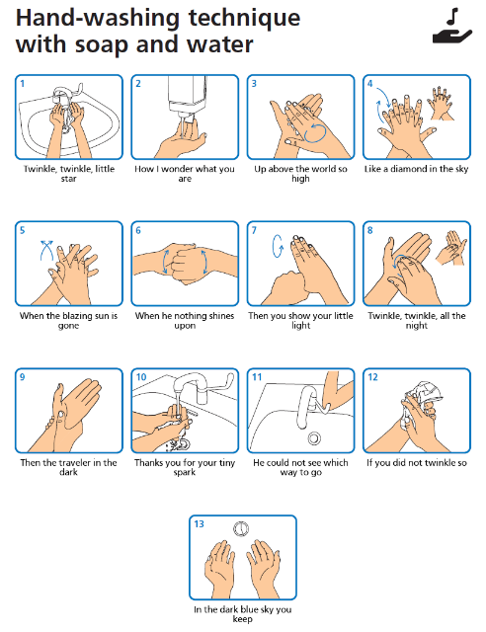
Take care of yourself and your stress so you can best help your children. https://store.samhsa.gov/system/files/sma14-4885.pdf

3/9/2020 This information condensed from:
- Talking to Children About COVID-19 (Coronavirus): A Parent Resource https://www.nasponline.org/resources-and-publications/resources-and-podcasts/school-climate-safety-and-crisis/health-crisis-resources/talking-to-children-about-covid-19-(coronavirus)-a-parent-resource
- How to talk to your kids about coronavirus by National Association of School Psychologists https://parenting.nytimes.com/childrens-health/coronavirus-kids-talk
- Talking to Kids About the Coronavirus https://childmind.org/article/talking-to-kids-about-the-coronavirus/
- Coronavirus (COVID-19): How to Talk to Your Child https://kidshealth.org/en/parents/coronavirus-how-talk-child.html
- How to Talk to Your Kids About Coronavirus https://www.pbs.org/parents/thrive/how-to-talk-to-your-kids-about-coronavirus

